* Check age is 32

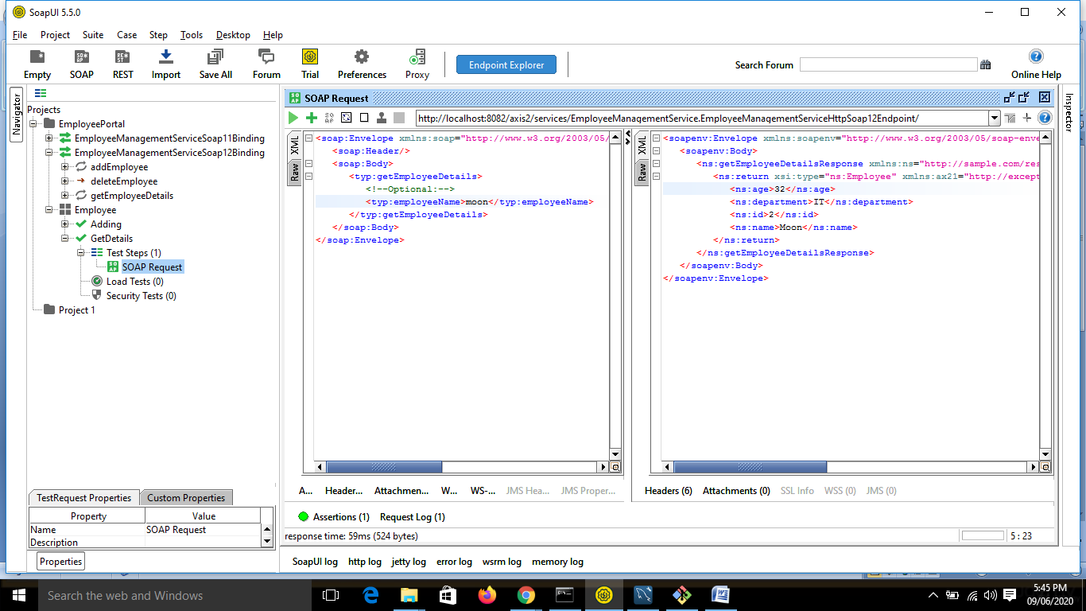

* XPath Match

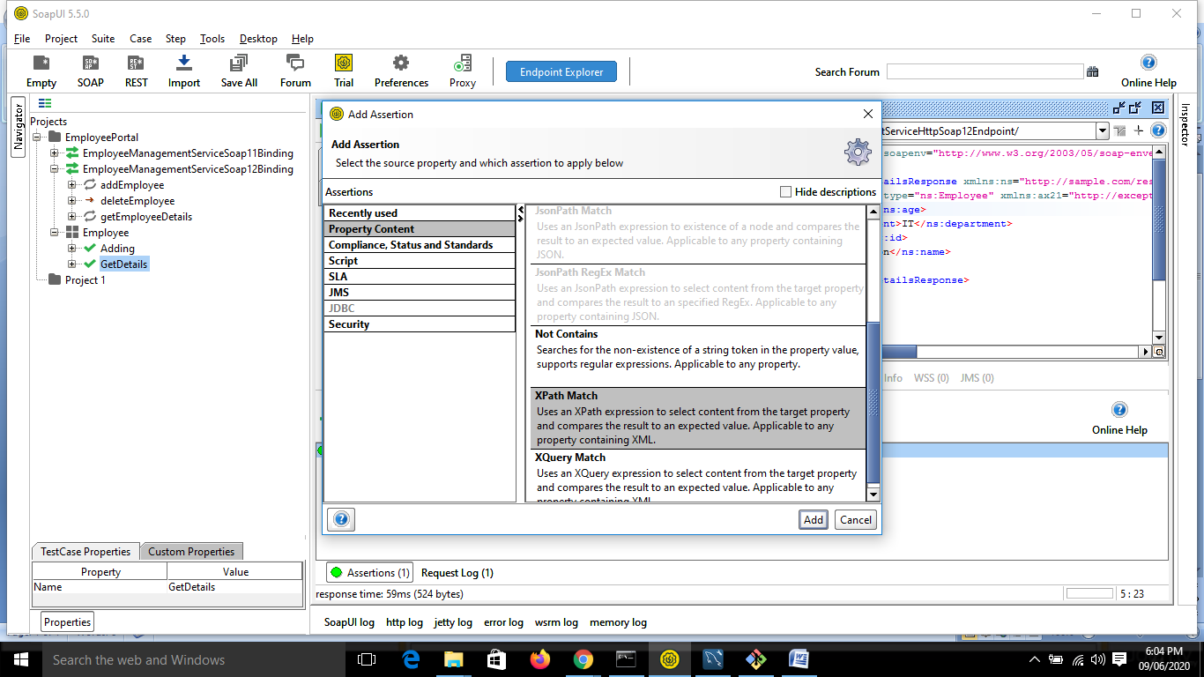

Click declare

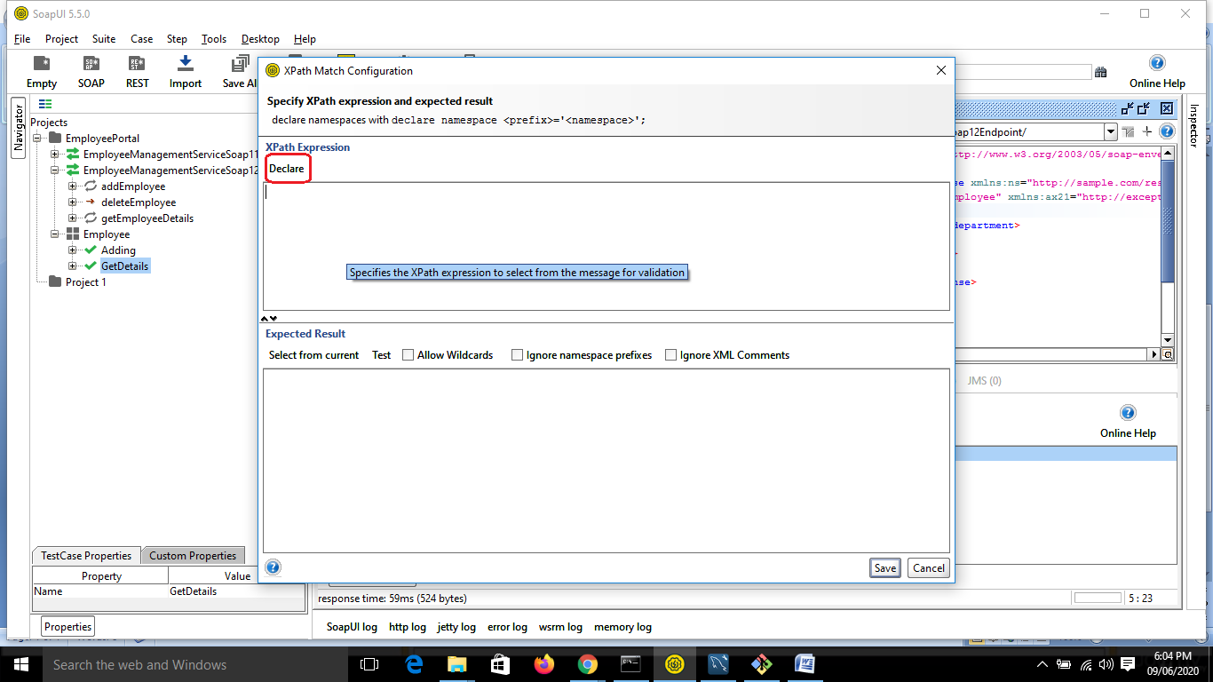

//ns:getEmployeeDetailsResponse/ns:return/ns:age

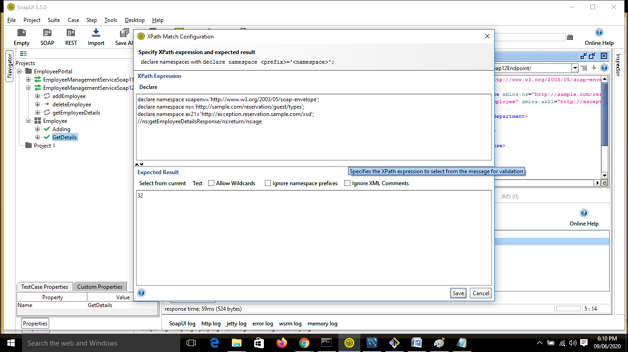

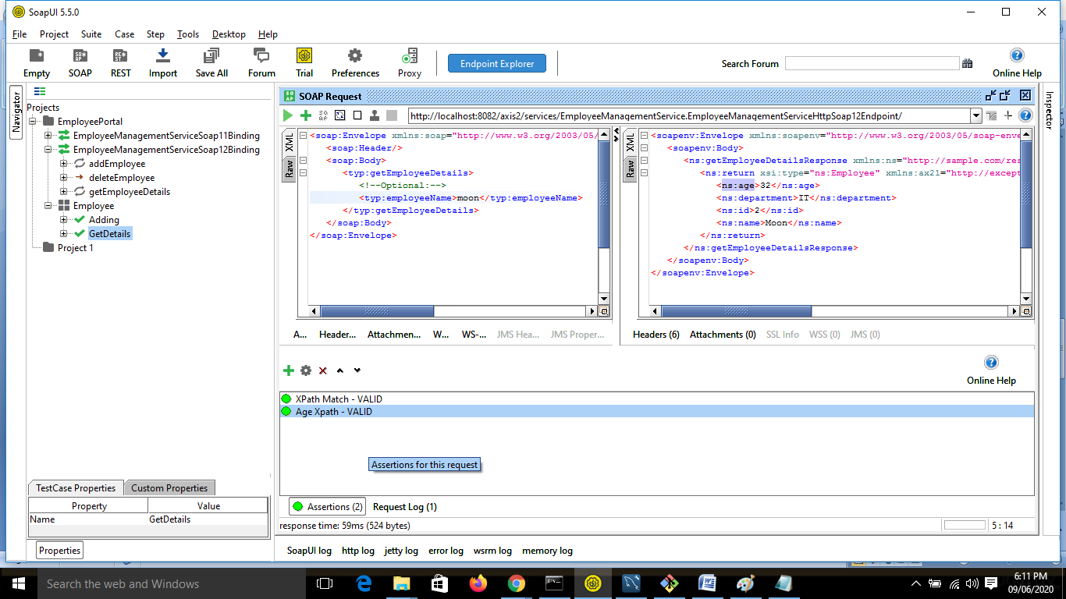

* Verify Department is IT

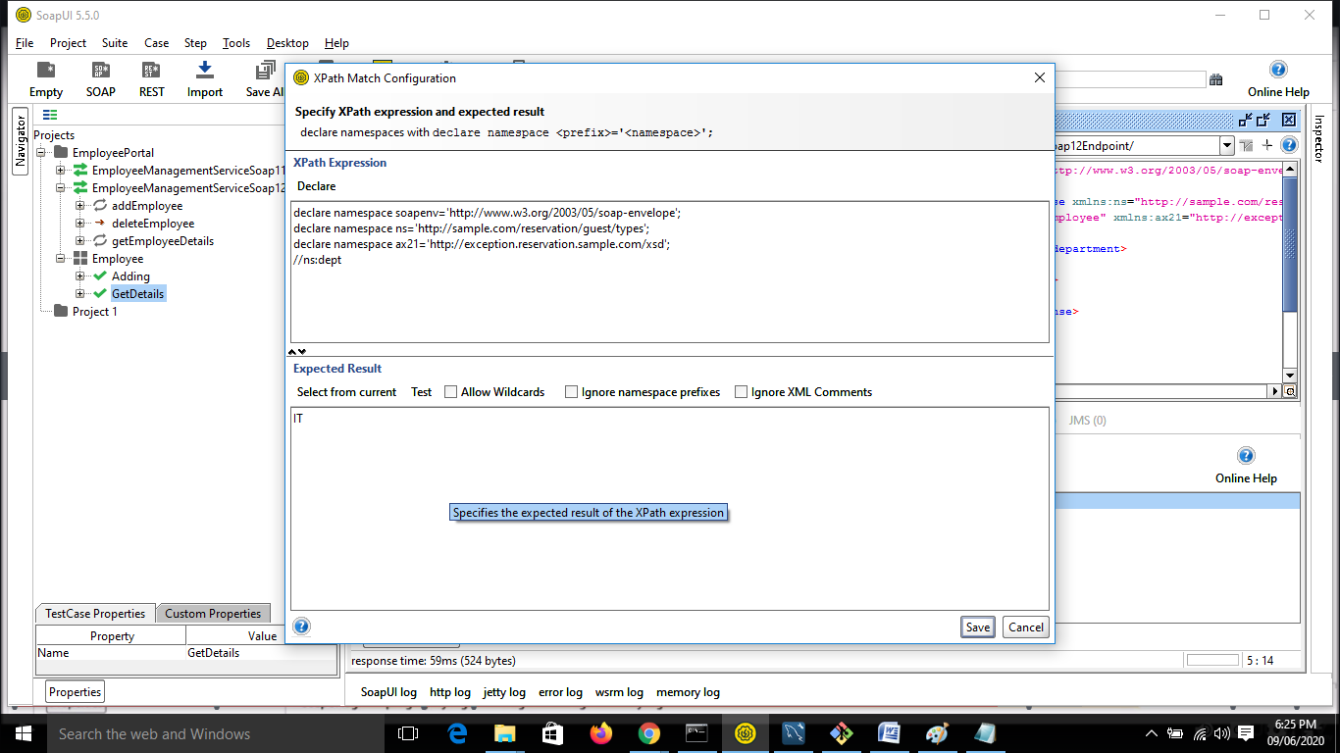

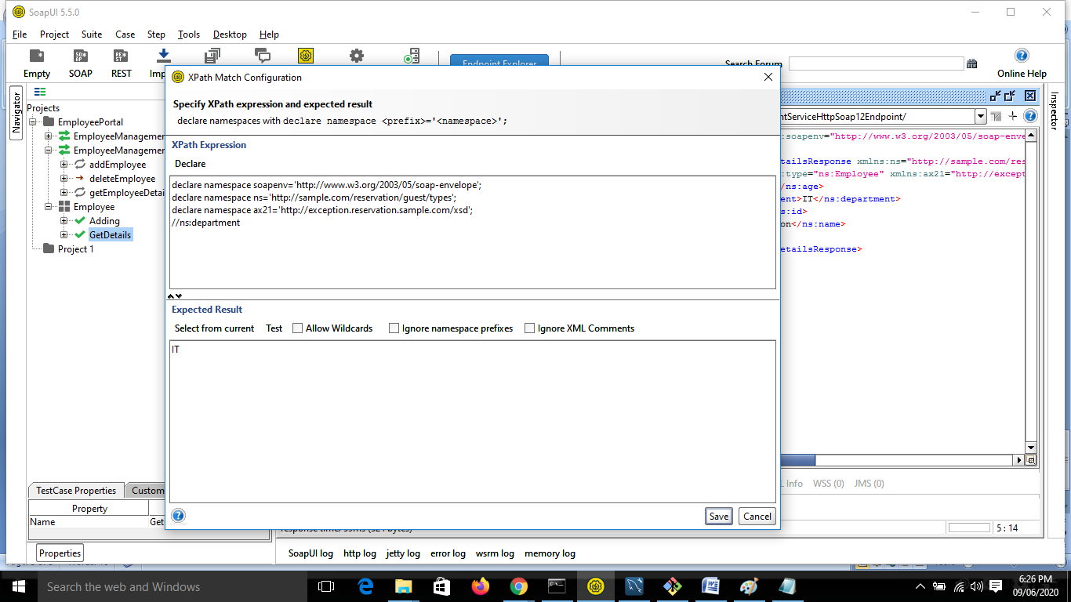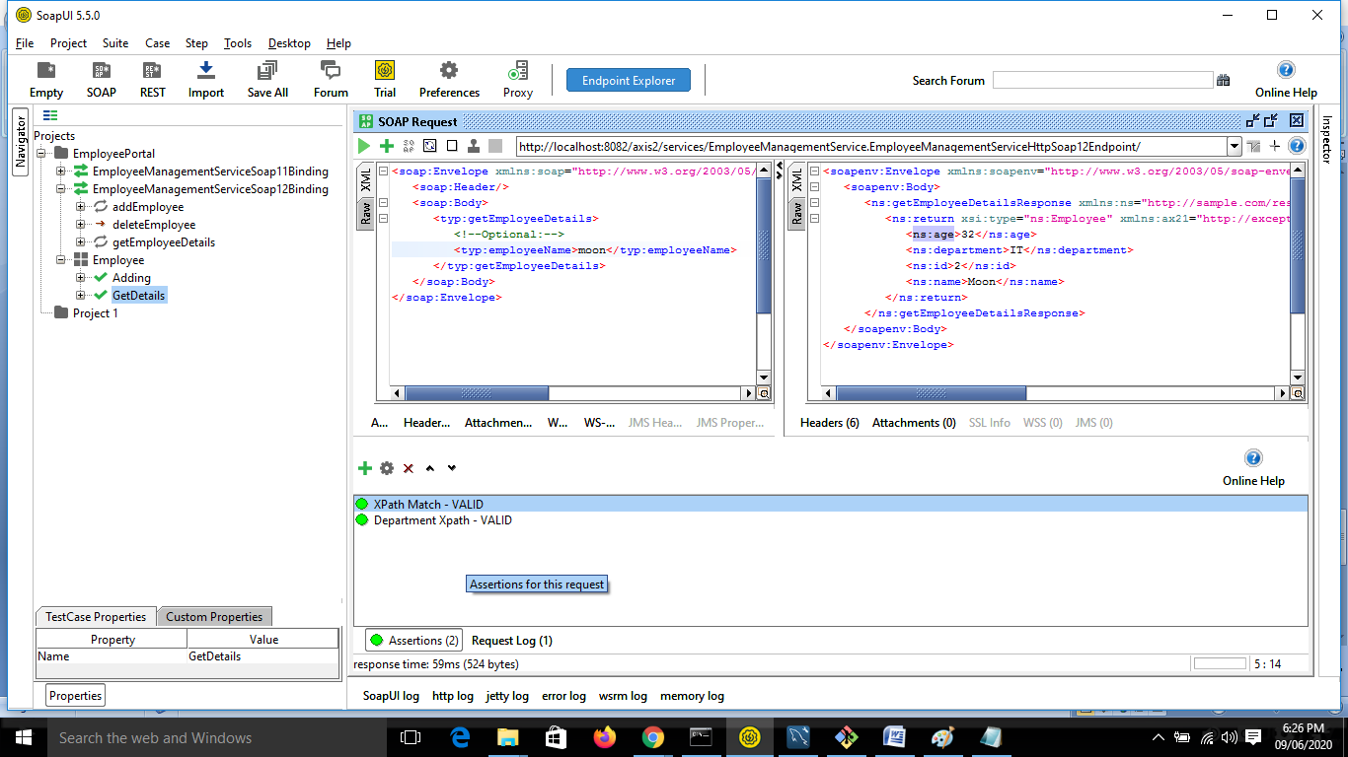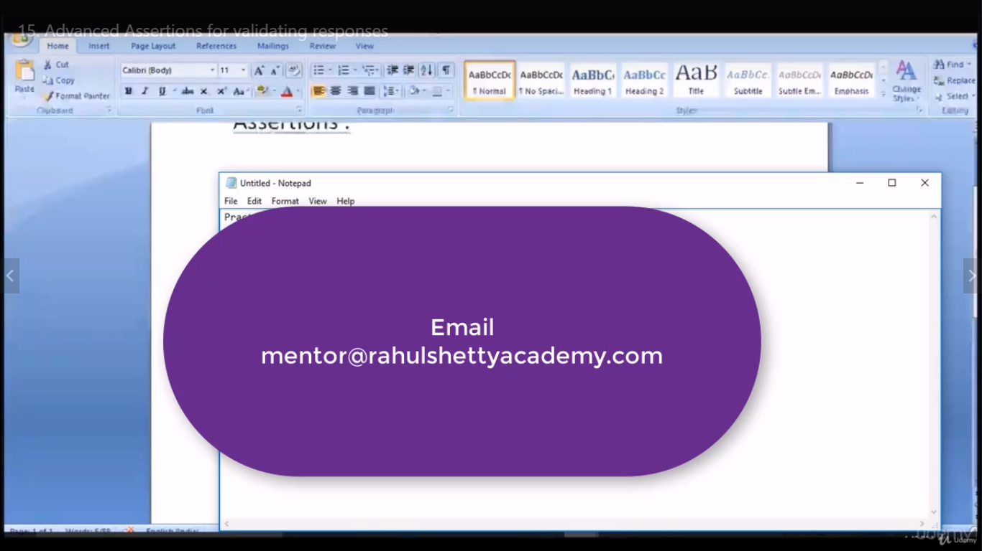Get Social with Rahul Shetty

**Get Social with Rahul Shetty in LinkedIn, Facebook and and stay updated with the best QA practices/ Latest Automation Job Openings in your area/QA Part time jobs and many more .**

**And also as a knowledge Share,  I am frequently posting new Updates about the trending testing tools in form of articles and Youtube video series. Make sure you follow them to emerge as Strong QA Test Evangelist**

**You can have your general questions too and get suggestions from the Strongest QA Community Base**

**LinkedIn**: <https://www.linkedin.com/in/rahul-shetty-trainer/>  
  
**FB QA Group** : <https://www.facebook.com/groups/RahulShettyAcademy/>

**Subscribe to our below YouTube channel for Automation Tidbits and many Miscellaneous Important QA General topics which needed for Real time projects. I often Conduct Online Automation Quizzes from my youtube channel and winners will be honoured with the best rewards.**

**YouTube**: <https://www.youtube.com/c/RahulShettyAcademy>